

Functional Specification Documentation

For
Pick and Pack

Version No.: 1.0
Date: 14th July 2016

Table of Content
1. Overview Details 3
1.1 Objective 3
2. Pick and Pack Manager – Open tab screen 0
3. Revised PO ETA Date listing 1
3. Outstanding SO Report 2

1. Overview Details

1.1 Objective

- Pick & Pack - to build a button to populate confirmed quantity to release quantity in pick & pack module to solve if the order need to release earlier than the confirmed delivery date.

- Revised PO ETA Date Listing.

- Outstanding SO Report.

2. Pick and Pack Manager – Open tab screen

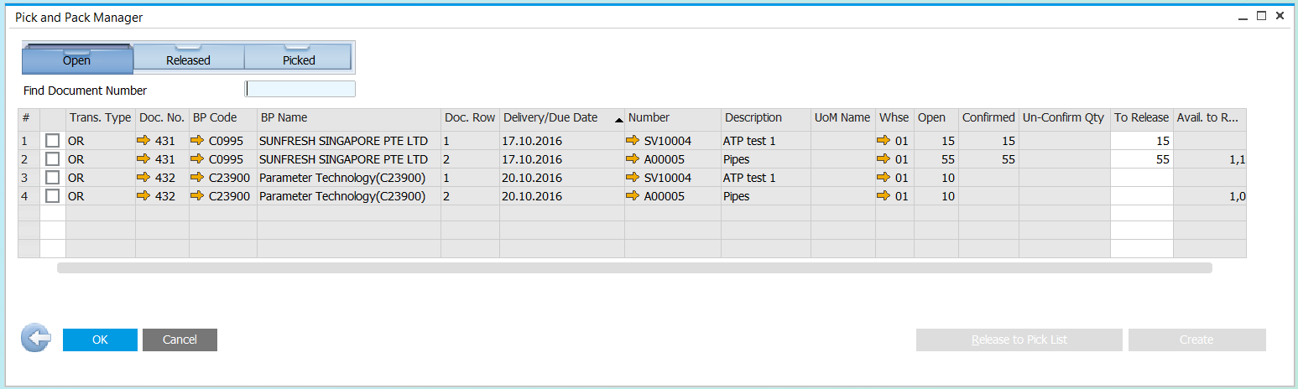
Copy Un-Confirm quantity

NO | Fields | System Action
 | Un-Confirm Qty | Get value from OSLD.CmfQty.  This will display only if Confirmed column is blank.
 | Click new button “Copy Un-Confirm Quantity” | Copy Un-confirm Qty to ‘To Release’ Column.  Copy only for those selected item in the pick list.

3. Revised PO ETA Date listing

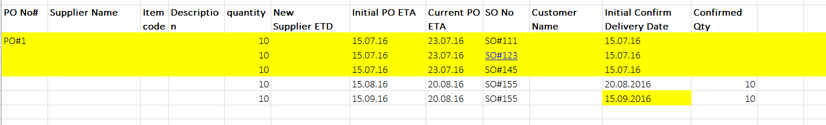

Parameter:
PO No:

Condition:
Reflected only when there is changes on PO ETA date / Production ETA date and the SO did not confirm Delivery details with the new PO ETA date.

NO | Fields | System Action
 | PO No#, | OPOR.DocNum
 | Supplier Name | OPOR.CardName
 | Item Code , Item Description | POR1.ItemCode, POR1. Dscription
 | Quantity | POR1."Quantity"
 | New Supplier ETD | POR1.U_SupplierETD
 | Initial PO ETA | POR1.U_OldPOETD
 | Current PO ETA | POR1.ShipDate
 | SO No | ORDR.DocNum
 | Customer Name | ORDR.CardName
 | Initial Confirm Delivery Date | OSLD.CfmDate
 | Confirmed Qty | OSLD.CfmQty

Outstanding SO Report

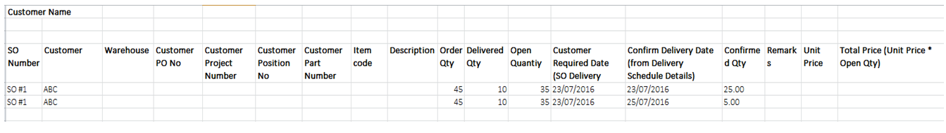

This report will show only:
  - SO line item that has yet to check availability
  - SO line item with default future date 31/12/3000 (this default date can be changed by Administrator after system go live)
NO | Fields | System Action
 | SO Number | ORDR.DocNum
 | Customer | ORDR.CardName
 | Warehouse | RDR1. Whse
 | Customer PO No | ORDR.NumAtCard
 | Customer Project Number | ORDR.U_ProjectNo
 | Customer Position No | ORDR.U_PositionNo
 | Customer Part Number | RDR1.SubCatnum
 | Item Code | RDR1.Itemcode
 | Description | RDR1. Dscription
 | Order Qty | RDR1.Quantity
 | Delivered Qty | RDR1."DelivrdQty"
 | Open Quantity | RDR1."OpenQty"
 | Customer Required Date | RDR1.ShipDate
 | Confirm Delivery Date | OSLD.CfmDate
 | Confirmed Qty | OSLD.CfmQty
 | Remark | ORDR.U_RemarkSA
 | Unit Price | RDR1.Price
 | Total Price | RDR1.LineTotal

